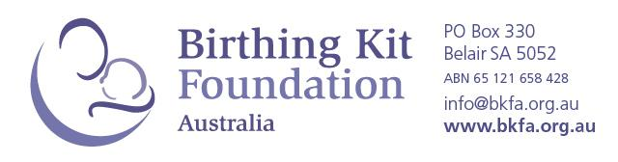
BIRTHING KIT GRANT
PERIOD: 1 JULY 2021 – 30 JUNE 2022
EXPRESSION OF INTEREST

About BKFA
Birthing Kit Foundation Australia (BKFA) respects people’s dignity, values, history and culture, and works according to the principles of basic human rights. We work with organisations that do not discriminate on the basis of gender, race, religion, political beliefs, marital status, disability, age or socio-economic status. We donate Birthing Kits to approved organisations for their distribution to pregnant women and maternal healthcare providers in low resource settings to help enable a safer and cleaner birthing environment.

What is a BKFA Birthing Kit Grant?

A Birthing Kit Grant is an agreed quantity of Birthing Kits that is donated and shipped (without charge) to a Field Partner throughout a 12-month period. Grants are awarded to new applicants and existing Field Partners on an annual basis. BKFA aims to maintain long-term partnerships and is committed to supporting trusted and high-performing organisations for a minimum of 3 years.

A – ORGANISATION
- Organisation name:
- Location of headquarters:
- Country of proposed Birthing Kit distribution:
If you plan to distribute Birthing Kits in more than one country, a separate EOI form must be completed for each country.
- Organisation legal status in country of proposed kit distribution: | ☐ Business or for-profit entity ☐ Charity or non-profit entity  ☐ Government entity ☐ Other:
- What projects does your organisation currently manage?
Please describe key objectives and scale (max. 200 words)
B – PROPOSED KIT DISTRIBUTION
- Locations of target populations:
Please include enough detail for us to find your locations on a map.
If possible, please include a map link or 3 word address from (www.what3words.com)
- Why are Birthing Kits needed in these locations?
Consider the level of awareness of clean birth practices and/or access to commodities (max. 250 words)
- How many kits will you require in a 12-month period?  BKFA does not award less than 200 kits or more than 20,000 kits per organisation per year. | Please describe how you have calculated the above request:
- How do you plan to integrate Birthing Kits into your existing or commencing projects?
(Max. 150 words)
- Are the BKFA Birthing Kits components acceptable for your projects and target populations?  Please review kit components at www.bkfa.org.au | Please describe your answer in detail, including how you know that the items are/are not suitable (max. 100 words):
C – CONTACT INFORMATION
PRIMARY CONTACT  This person will receive all correspondence related to the BKFA Birthing Kit Grant Program | - Title: | ☐Mr ☐Mrs ☐Miss ☐Other:
 | - Last name:
 | - First name(s):
- Preferred name:
We will use this name for everyday emails and informal communication. Include title if preferred.
 | - Email address:
- How did you hear about BKFA Birthing Kits? | ☐ Internet search  ☐ Friend/colleague  ☐ Other organisation:  ☐ Other:

How to submit your application | Please email your completed Expression of Interest Application to: programs@bkfa.org.au by the 31 July 2021.

Thank you for your interest in working with Birthing Kit Foundation Australia.
Sometimes emails sent from programs@bkfa.org.au are incorrectly filtered by your email provider as spam or junk. Please check you spam and junk email folder for a reply to your EOI.

